Christian Clark

CIS 123

Algorithm Workbench

#2. AddThree.asm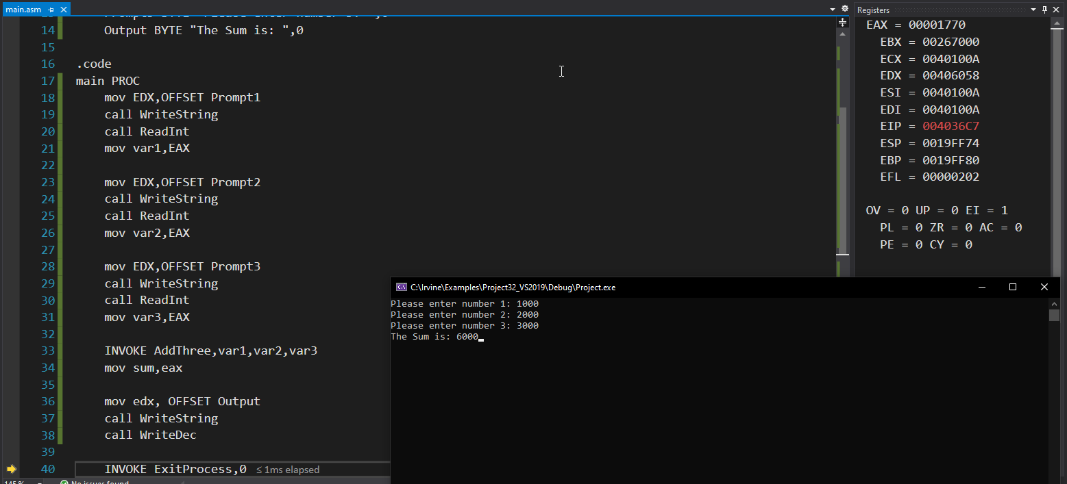

#3. PTR to DWORD pARRAY.asm (Extra one to make up for the lack of review questions)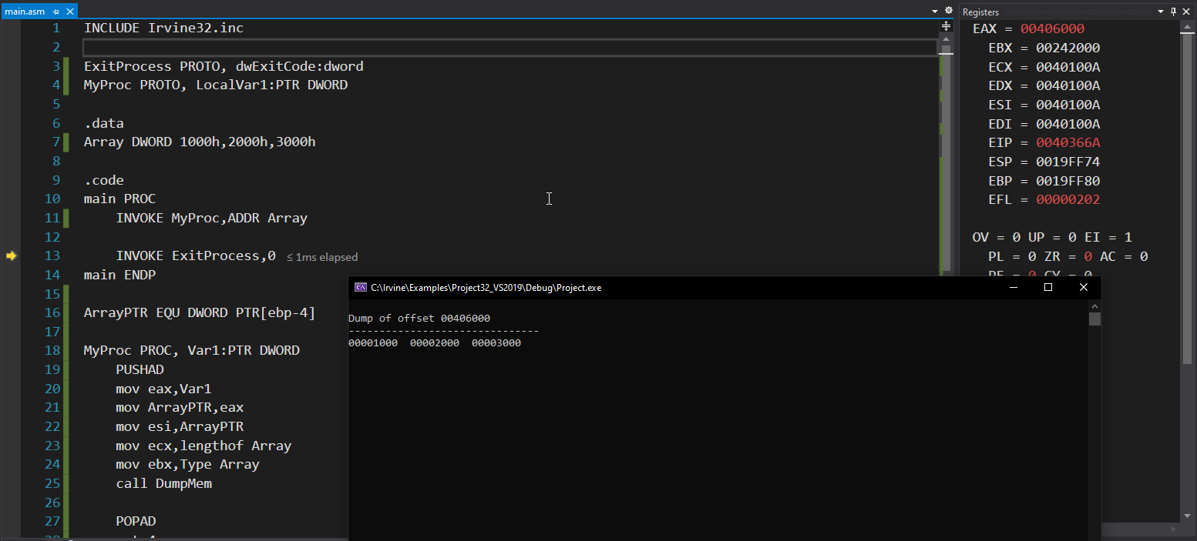

#9. WriteColorChar.asm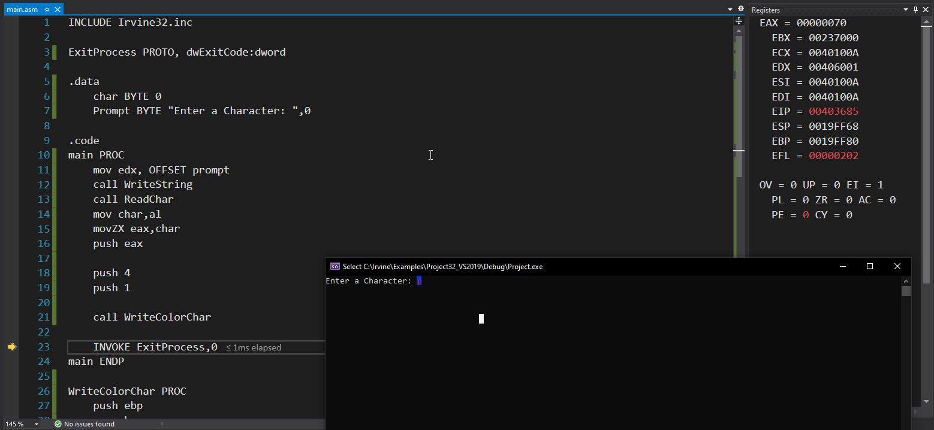

Programming exercise #4 FindThrees.asm